THE CAUSE OF THE PRODUCT FAILURE AND ITS TREATMENT METHOD

Phenomenon | Cause | Solution
Difficulty Igniting  Or  It doesn't catch fire | Use of other gas cylinder brands containing excessive air | Use a standard gas cylinder
Difficulty Igniting  Or  It doesn't catch fire | The ignition porcelain needle is misaligned or incompatible. | Adjust the gap between the porcelain needle and the fire cover to approximately 4 mm.
Difficulty Igniting  Or  It doesn't catch fire | The ignition porcelain needle is contaminated | Clean it thoroughly and wipe it dry
Difficulty Igniting  Or  It doesn't catch fire | Electronic wire leakage | Check whether the wire has become detached. If there is any leakage, secure it with insulating tape or replace the electronic components.
Produces yellow flames | Nozzle misalignment and presence of foreign objects or spider web in the air intake | Realign the nozzle and remove any foreign objects
The fire is uneven | There is a foreign body in the burnt hole | Remove the foreign object from the burnt hole carefully. Ensure the unit is powered off and unplugged before cleaning.
Flame turning off | Excessive air in the air duct (may be the cause of the new cylinder) | Allow the unit to run for a few minutes, then adjust the nozzle angle as needed
Can't put out the fire | The valve body switch is faulty | Send for repair
The switch lever does not move | Body switch failure (oil drying up) | Send for repair
Load the cylinder and ignite without delay | Cylinder pressure is too high | Replace with a new cylinder, or cool the cylinder with cold water before use

“Honor your father and mother so that you may live long
In the land the lord your god is giving you”
Exodus 20:12

Cherenz Global Mfg. Inc., distributor of Tough Mama Home
and Kitchen Appliances, shall not be responsible for any fire, scalding or
injury from misuse or negligence from the use thereof.



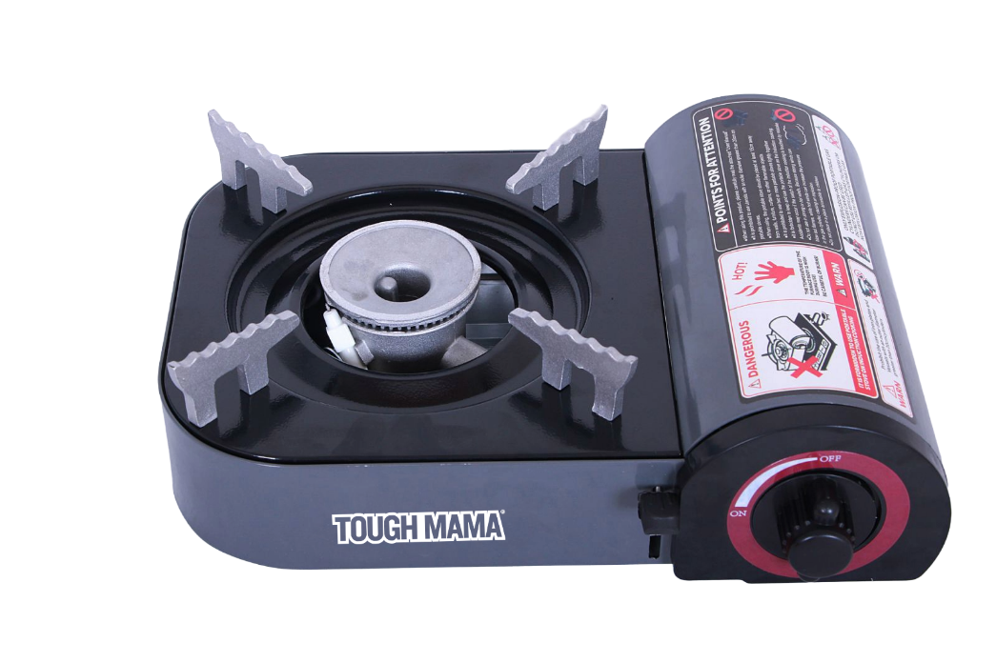

INSTRUCTION MANUAL
PORTABLE GAS STOVE
Model No.: NTMPGS-3

READ AND SAVE INSTRUCTIONS

PRODUCT NAME AND SPECIFICATIONS

Name of article | Portable butane gas stove | Air consumption | 110g/h (at room temperature 20℃)
Ignition method | Pull rod/magnetic suction type | Bring water to a boil | 1kg, in a 20cm stainless steel pan for 9 minutes
Use an air source | Portable butane gas(bottle) | Product size | 250*206*88mm

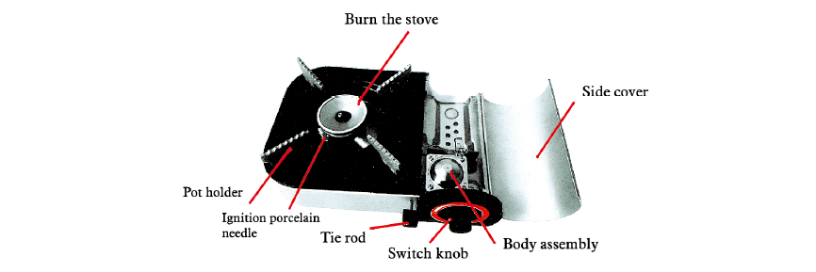
Burner of the stove
PART NAMES

DIAGRAM
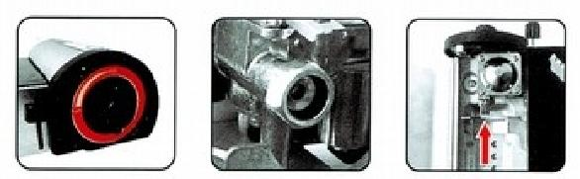

Figure 1 | Figure 2 | Figure 3
The knob is closed in position | There is no foreign matter on the stuck gas head and must be cleaned | The notch of the tank  is aligned with the card slot
IMPORTANT SAFEGUARDS

1. This appliance is not intended for use by persons (including children) with reduced physical, sensory or mental capabilities, or lack of experience and knowledge, unless they have been given supervision or instruction concerning use of the appliance by a person responsible for their safety.
2. Children should be supervised to ensure that they do not play with the appliance.
3. This appliance is intended to be used in household and similar applications such as:
- Staff kitchen areas in shops, offices, and other working environments;
- Farm houses;
- By clients in hotels, motels and other residential type environments;
- Bed and breakfast type environments.
4. The appliance must not be immersed in water or any other liquids.
5. Caution: Hot Surface.

1.Product features:
Aluminum alloy shell, surface brushed and oxidized treatment, never fade, beautiful and more durable.
1. Make sure the switch knob is in the "OFF" position (Figure 1). The cylinder cannot be installed if the knob is not fully closed. Open the side cover and check the air head for any foreign objects (e.g., vegetable residue or other debris). If present, clean with a dry cloth (Figure 2) Insert the gas cylinder, aligning its mouth with the gas inlet. Then close the side cover securely.
2. Ignition: Rotate the switch counterclockwise until you hear a “pop” sound — this indicates ignition (Figure 4). If it does not ignite on the first attempt, repeat the ignition process. Note: Keep your head and face away from the stove at all times. If the stove fails to ignite after three or four attempts, stop and check the cause before using. Refer to the Product Failure and Abnormality section for troubleshooting.
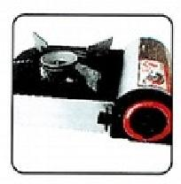
3.Terminate: Rotate the switch clockwise to the “OFF” position (Figure 1). Open the side cover, remove the gas cylinder, then close the side cover. Store the gas cylinder and stove separately. Figure 4

2. Overvoltage Protection:
If the appliance is used improperly, or if the temperature becomes too high and the pressure inside the cylinder exceeds 0.45 MPa to 0.7 MPa, the overpressure protection device will automatically activate, ejecting the cylinder and stopping combustion.
To continue using the appliance, remove the cylinder and cool it with cold water. Once the pressure drops below 0.4 MPa, reinstall the cylinder. If the pressure remains high, the cylinder will eject again and cannot be installed. You may also replace it with a new cylinder before resuming use.
3. Precautions:
1. Keep away from children – Do not allow children to touch or play with the stove.
2. Safe distance from flammables – Keep flammable and explosive materials at least 30 cm away from the stove while it is operating.
3. Avoid overfilling cookware – Do not overfill pots or pans to prevent boiling over, which may cause the flame to extinguish or gas to leak.
4. Prevent burns – Do not touch the stove frame or burner during or immediately after use, as they remain hot. Wait until the stove has cooled completely before cleaning, storing, or handling.
5. Proper storage – Remove the gas cylinder before storing the stove. Store the cylinder separately in a safe place, out of children’s reach.
6.Authorized repairs only – Do not disassemble or modify the stove yourself, especially the valve body assembly. For repairs, contact your dealer or an authorized service center.
